**Python Programming**

**Technical Document**

**CS1030**

**Jimmy Torres**

**Table of Contents**

1. **Variables, Data types, and Methods.**

**a.) Variables**

**b.) Data Types**

**c.) Methods**

1. **Selections and Inputs**

**a.) Reading Input**

**b.) Conditions**

1. **Loops and Algorithms**

**a.) while Loops**

**b.) for Loops**

**c.) Algorithms**

1. **Misc. Methods**

**a.)**

**b.)**

**c.)**

**Variables, Data types, and Methods**

**Variables**

**a.)** A variable is a piece of data/value. A variable is assigned with a single, = , and tells the program that the following data type is assigned to the variable on the left of the equal sign. Different data types can be assigned such as, a **string (“ “/’ ‘)**, **integer(int)**, **float**, and **Boolean(True or false). Lists** These are saved on the local device's resources(memory).

**Data Types**

**b.) Strings** appear as they are. With a matching pair of single or double quotes at the beginning and end of the item, the string of characters are defined. Numbers that are portrayed as strings such as “3”, cannot be used to calculate problems.

Strings may be able to be formatted. With the example of “3” in the previous paragraph, a person’s age may be represented by a variable called **person_age** and assigned a value of “3”. With another variable, a user can “add” the person_age variable to the current variable to make a new string. Below is an example.

Code:

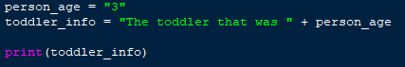

Output:

**Integers** are whole numbers and are used to calculate math problems. Integers cannot be used with floating numbers unless they are converted to the appropriate data type. Integers are defined with a parenthesis and ‘int’. variable = int(3) is an example of this.

Code:

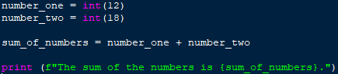

Output:

**Floats** are used to indicate a floating number. A floating number is used to display decimal values up to 32 bits. All float values always have a decimal value. Pi is equal to 3.14159265359… and is an example of a float. Currency requires float numbers or it will not show decimal/cent value.

Code:

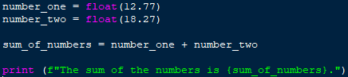

Output:

Floats may require instances where rounding is necessary. If a value needs rounding, the **round** method needs to be used with an argument of **2** as the last number. The following example is used with the value of pi.

Code:

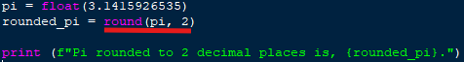

Output:

In specific circumstances, an integer may need to be converted to a float, or vice versa. To do this, a new variable must come after the original variable annotating what it’s new datatype is.

Code example of float to integer:

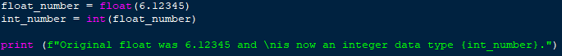

Output:



Code example of integer to float:

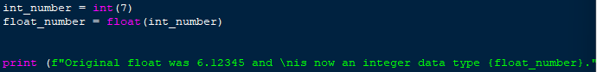

Output:



**Booleans** are used to identify true or false statements. An example of this is using any of the following relational operators to compare values in a Boolean statement:

**< — Less than**

**> — Greater than**

== **— Equal to (can also be used with string values)**

**<= — Less than or equal to**

**>= — Greater than or equal to**

**!= — Not equal to (can also be used with string values)**

Using the print method to visualize this logic, a non-string comparison of numbers can be compared and the computer can interpret the information. The following example compares the value of 1 to another 1.

Code:



Output:



In short, **1 is equal to 1**, and any other comparison is **False**. When a user is not using the print method, this may be used in conditional loops such as, **while** **True** loops, and **if** statements. Review the loops section in this document to view examples of practical uses of this logic.

**Lists** are used to either have several values saved in the using device’s memory, or store future inputs or new values that become calculated later. List variables use a matching pair of brackets, **[ ]** , to contain items. The below example shows string values saved in a variable called list_example. Lists are used to store single items, several items, or no items at all.

Example of a list variable being used with several list items:



Output:



Using the **print** method for a list without a **for** loop may cause the list to print exactly the way it appears in the code.

Example of using **print** without a **for** loop:



Output:



The reason for this is that the computer does not know how the user wants the information to be displayed. A **for** loop works line-by-line through each **list** item until there are no items left. The result is a printed list that appears as a column.

Example of a **list** variable with **no** **values** assigned:

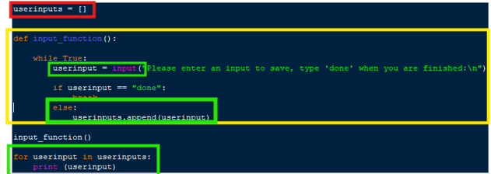

Output:

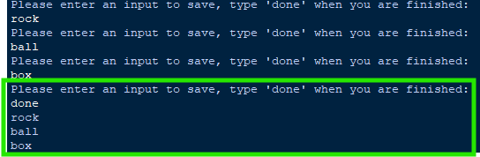

The **red boxed** variable is an empty list. The function in the **yellow box** allows the user to type and enter **inputs** as **string**s. The **userinput** variable asks for a value be entered. As long as the user does not type ‘**done’**, the value entered will be added to the ***userinputs*** ***list***. This is done using the method named, **userinputs.append(userinput).**

Explanation of **list** items in **green** boxes:

**Userinput** is a variable that only takes one input at a time. Using the **userinputs.append** method, items are added to the ***userinputs*** list.

With an argument of **(userinput)**, the program knows to add the userinput variable to the ***userinputs*** list. When the loop restarts, the process starts over and the previous userinput is changed, and then added to the list of **userinputs** that have been accumulating. The only way to **break** the loop is to type, ‘**done’**.

**Methods**

**c.)** A method is a function. Unlike a variable, a method can pass information (arguments). Some methods return information.

Print is a method. A method needs an argument, and is annotated in parenthesis. Using print to display a string, the following example shows how print is used with parentheses and double quotes at the beginning and end of the string:

Code:



Output:



**Print** can also use **formatting** to print existing variables. Using an **f** inside the argument, but outside the quote marks, a user can add variables to print. Using curly brackets, a user can name the variables to display in the output. Below is an example of print being used with formatting:

Code:

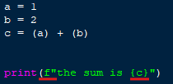

Output:



Other examples such as **round** , **.append** , **.lower** , **.upper** , **.join** , are examples of methods to make an action occur. Methods depending on their usage can manipulate information and create new outputs for other parts of a code.

**Selections and Inputs**

**Reading Input**

**a.)** Input is what the user is putting into an application or code. This document is typed with a keyboard and every button pressed is an input. It is the computer’s job to make an output, which in this case is the text appearing on this document.

With python, a code or program may be written to receive input before making further outputs. This may be any type of data type needed to continue using the program. Below is an example of a user being asked to enter their favorite color.

Code:

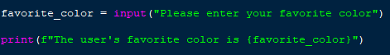

Output:



The **favorite_color** variable was empty before the input ‘black’ was entered. Because the variable was changed to the value of ‘black’, the **print** line of code had used the newly assigned value for the output.

This same method can be used for calculating unknown math problems. This example turns the input string into an integer, then the program can interpret the information correctly.

Code:

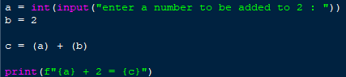

Output:



**Conditions**

**b.)** Conditions are used to ensure a specific set of parameters are met. This requires a loop in order to cycle through the different possibilities. In a scenario where a loop is continuously not getting the correct input, it go on indefinitely.

The **if** condition can be set up to meet certain conditions. Building on the last example of using **input**, this line of code takes an input to be added. If the result is equal to ( **==** ) 5, it will print a string to tell the user they are right. Any other result (‘**else’**) results in a statement that indicates they are wrong.

Code:

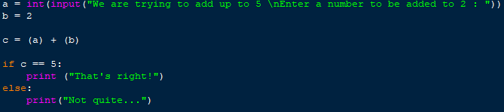

Output #1:



In this circumstance, the **condition** that was **equal** to 5 was met“That’s right!”, was printed as a result.

Output #2:



In this circumstance, the input did not equal 5 and the **else** condition printed a different string.

The next section gives 2 other examples with more detail about **if**, **elif**, **else**, in a **while True** loop.

**Loops and Algorithms**

**While Loops**

**a.)** **while** loops are used to indicate that while a certain variable or condition is **true** or **false**, a set of conditions are to occur. Including ‘**while True**:’ to the beginning of a condition can make the conditional statement into a loop. The purpose of this is to force a specific set of parameters be met, in order to make use of the input or output of a piece of code.

The issue with **while** loops is if they are incorrectly written, they continue to run through the section of code indefinitely (or until the program crashes). To prevent this, the following needs to be implemented:

* The variable requiring input (if any) must be added after the **while True:** loop starts, and BEFORE the variable that will be **true** or **false**.
* The variable being checked for **true** or **false** must be placed before the conditional statements start (**if,** **if not** , etc.).
* The first condition is always **if** (or **if not**) and is followed by a relational operator (see example).
  + The **if** statement requires that something happens (what happens if condition is met).
* **elif** is always the next conditional statement. It is formatted in the same way that, **if,** is formatted but must either have a different relational operator, or it must have a different condition that is met. Contradicting statements will cause errors.
* **else** refers to all other circumstances of comparing that are not applied. Else applies to every condition that is not already listed. If an error occurs with this condition, there is a syntax error (such as a string being entered as an input, when an integer is required).
* In the event that **else** is used**,** it should be used in the last condition of the loop.
* There must be a ‘**break**’, or a call for a **function,** to stop the loop.

Code for a while True using only **elif**:

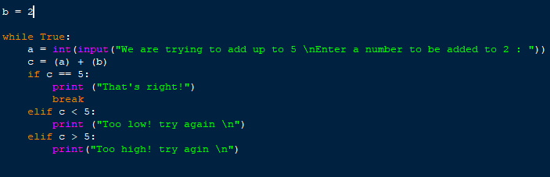

Output:

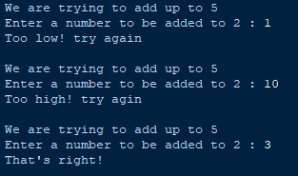

Code for a while True using **else** instead of elif:

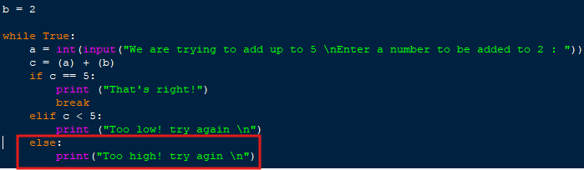

Output (same output as the other example):

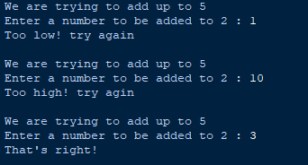

The previous 2 examples show that the output of the ‘c’ variable needs to be equal to ‘5’ to break the loop. The conditions without a ‘**break**’ keep the loop continuing until the input completes the sum. When the user enters an integer value of ‘3’, the loop stops. If ‘**break’** is removed from the if condition, the loop is never completed.

**for Loops**

**b.)** For loops are used to repeat tasks for a set amount of times. **for** loops are useful giving outputs to the user. A **for** loop consists of a **list** or **dictionary**, an **argument** with **integers**, and a method such as **print**.

A **for** loop can be used in calculating math problems that may repeat several times (see example) and printing series of strings.

In this example, **for** starts the loop. **i** is the name given to the items that will be printed. Any name can be given to these items and the way this is assigned is similar to a variable being assigned a name. **in** **range** is specific to going through a specific range of numbers in the **argument / ()**.

The **argument**’s first number is **1**. This number indicates that the range starts counting at 1. It is important to note that python always starts counting at **0**. This means if a user wants a range of 9, it will stop at 8, because it started counting at 0. The reason for this is computers count in binary, and values range from 0 to 9 before beginning to reuse these values for larger numbers.

The second number in the **argument** is the user input, which will set the max number to whatever the user wants.

The third number in the **argument** indicates that the range will start counting with an offset number of **+1** from 0. This means it will start counting at **1** and not **0**. This is done to not confuse the user when the output is one less number than they had entered.

The multi_table variable is the calculation that will be repeated based on the user’s input. For every iteration, **i** will gain a value of **1**. With this in mind, it will be used to multiply the variable in the multiplication problem until the range’s highest number is met. **print** follows this line of code as the final step in this loop. When the loop runs, this **algorithm** repeats the process until the **range** is complete.

Code of a **for** loop used to create a multiplication table.

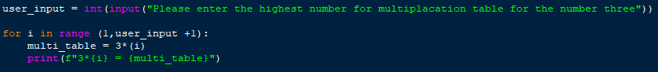

Output:

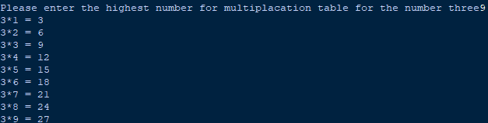

Code of a **list** being printed in order of when the items were added:

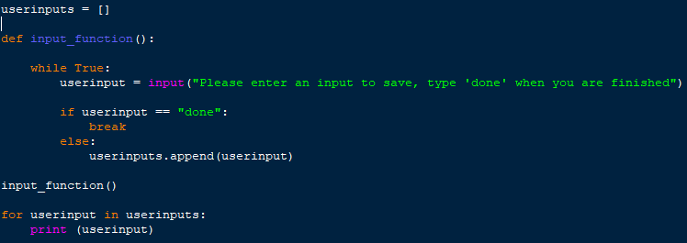

Output:

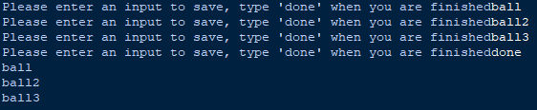

Algorithms

c.) **Algorithms** are a series of steps toward a specific objective. PEMDAS is an algorithm used in math toward solving long math problems. The same applies for Rubik’s cube solving, as a user will need to understand steps toward completing layers of colors before finishing the last side of the cube.

When writing functions, loops, etc., a user is developing an algorithm (set of steps) that the program will follow toward giving an output. In python, the higher the line of code is in the **hierarchy,** the sooner it will be executed in the output.

To create a more flexible program, a user can make blocks of code that don’t execute until it is **called**. A **function** follows this circumstance. Functions allow a user to call a section of code only when it’s necessary to use. Functions can call other functions if the user decides, and make it easier to organize sophisticated code.

Functions require that they be **defined**. Defining a function is straight-forward, as they only contain code that function will execute.

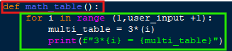

This function only has a **for** loop and will not be executed unless **math_table()** is called somewhere in the code. The example shown has a **variable** in the **for** loop that is not defined in the **function**.

Variables outside of a function can be called from inside the function.

Code:

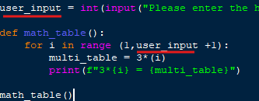

Output:

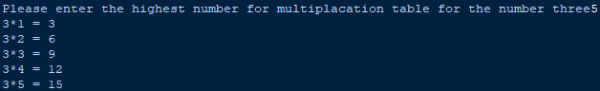

However, a variable created inside a function requires two additional steps. The user needs to **return** the variable at the end of the function. Second, the same variable needs to be created outside of the function with it assigned to the function name where it originated from.

Example:

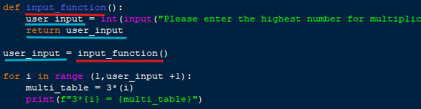

In more complex functions, a user may need to use an **input** across several functions. The following example shows a variable called, ‘**zero’** with an integer value of **0** being passed through two functions and into a separate **for** loop. The following steps are taken:

* **Return** the **input** variable at the end of the first function.
* Naming the variable **outside** of the function with the original function assigned to it.
* **Add the variable as an argument to the next function that will use it. *This step carries the variable to the next function so it can be used.***

At this point a new variable called **sum_didnt_change** uses the carried variable **zero** for a calculation.

* Return the new variable at the end of the function.
* Name the variable **outside** of the function with the name of it’s corresponding function assigned to it.
* Use the **variable** where it’s needed.

All the repetitive lines of code are highlighted below. Note that the variable **zero** (yellow) is passed more times than all other items.

Example of a variable being passed on to other functions:

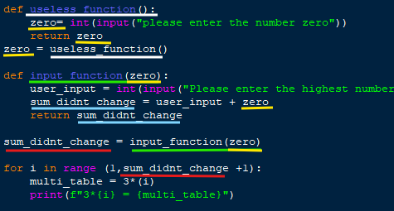

The following program is made for playing rock, paper, scissors against a computer. The program is designed to work out of the **introduction()** function (Fig. 1).

Fig. 1:

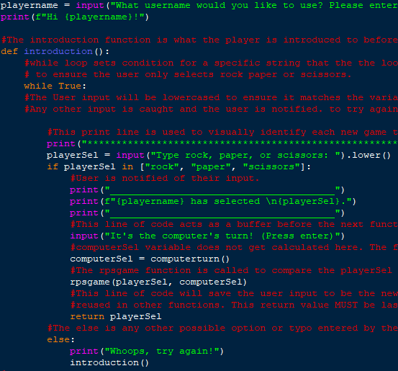

If a user inputs a string from the list in the **if** statement, it continues to the next line of code, **computerSel=computerturn().** In simple context, the resulting output of **computerturn()** will be assigned to the **computerSel** variable (Fig. 2). This computerturn function picks a random string value of rock, paper, or scissors by the computer.

The function, **rpsgame**, is called to compare values of the player and computer. **playerSel** and **computerturn** are in the argument so the function knows to bring these two values to the next function (Fig. 3).

***Note that return playerSel is used at the bottom of this condition to keep the playerSel value saved for the next function***.

The other **if** condition for **else** in Fig. 1 is used to prevent the user from entering a random input that cant be used. In the event that this condition is not stated, the program will not know what to do and create an error if the user typed ‘rck’ instead of ‘rock’.

Fig 2:

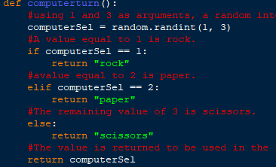

Fig 3:

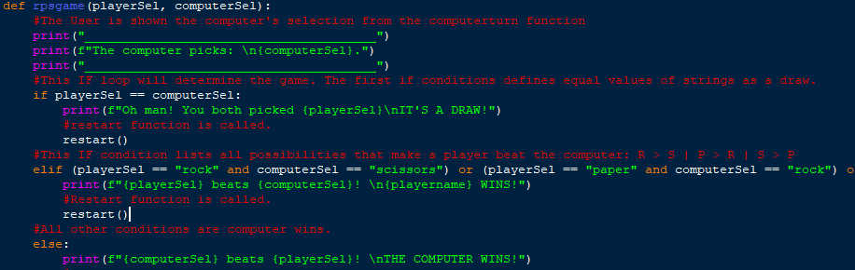

(Output on next page.)

Output:

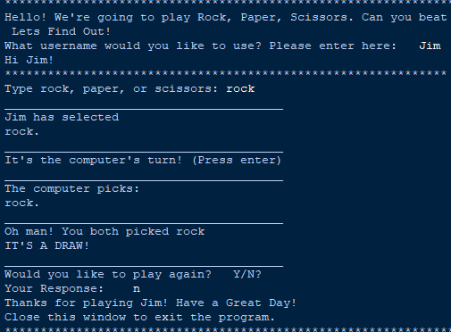

This program uses several **functions** to complete a game of rock, paper, scissors. With several possibilities of how any one game can turn out, an **algorithm** is required to get to the end result. The purpose for this is to ensure the program is robust, accurate, and eliminates any possibility of an error occurring from within the parameters of the code.